**Lab 6**

**Python**

**Name:** Etcherla Sai Manoj **Mis. No:** 112015044 **Branch:** CSE

**Question:**

**Code:**

from tkinter import *

listN = []

listE = []

listB = []

listM = []

listS = []

listR = []

def clear():

    file = open("C:\\Users\\DELL\\OneDrive\\Desktop\\Labs\\lab_6.txt", "w")

    file.close()

    print("cleared")

def search():

   n=input7.get()

   for x in listN:

      if(x == input7.get()):

          print("found")

          ind=listN.index(x)

          print("Name: ",listN[ind])

          print("Email: ",listE[ind])

          print("Branch: ",listB[ind])

          print("MIS: ",listM[ind])

          print("Semester: ",listS[ind])

          print("Result: ",listR[ind])

   if(n not in listN):

      print("notfound")

def save():

    file = open("C:\\Users\\DELL\\OneDrive\\Desktop\\Labs\\lab_6.txt" ,"at")

    file.write("Name = "+input1.get()+"\n")

    listN.append(input1.get())

    file.write("Email = " + input2.get()+"\n")

    listE.append(input2.get())

    file.write("Branch = " + input3.get() + "\n")

    listB.append(input3.get())

    file.write("MIS = " + input4.get() + "\n")

    listM.append(input4.get())

    file.write("Semester = " + input5.get() + "\n")

    listS.append(input5.get())

    file.write("Result = " + input6.get() + "\n")

    listR.append(input6.get())

    print("saved")

root = Tk()

root.title("form")

l = Label(text="USER DETAILS", fg="black")

l.grid(row=0, column=5)

label1 = Label(text="Name", fg="red")

label1.grid(row=4, column=0)

input1 = Entry(root, width=50)

input1.grid(row=4, column=1)

label2 = Label(text="Email", fg="red")

label2.grid(row=5, column=0)

input2 = Entry(root, width=50)

input2.grid(row=5, column=1)

label3 = Label(text="Branch", fg="red")

label3.grid(row=6, column=0)

input3 = Entry(root, width=50)

input3.grid(row=6, column=1)

label4 = Label(text="MIS number", fg="red")

label4.grid(row=7, column=0)

input4 = Entry(root, width=50)

input4.grid(row=7, column=1)

label5 = Label(text="Semester", fg="red")

label5.grid(row=8, column=0)

input5 = Entry(root, width=50)

input5.grid(row=8, column=1)

label6 = Label(text="Result", fg="red")

label6.grid(row=9, column=0)

input6 = Entry(root, width=50)

input6.grid(row=9, column=1)

b1 = Button(root, text="save", command=save, bg="grey")

b1.grid(row=15, column=0)

b3 = Button(root, text="clear", command=clear, bg="grey")

b3.grid(row=15, column=4)

input7 = Entry(root,width = 50)

input7.grid(row = 22, column = 1)

b2 = Button(root, text="Search", command=search, bg="grey")

b2.grid(row=22, column=2)

root.mainloop()

**Output:**

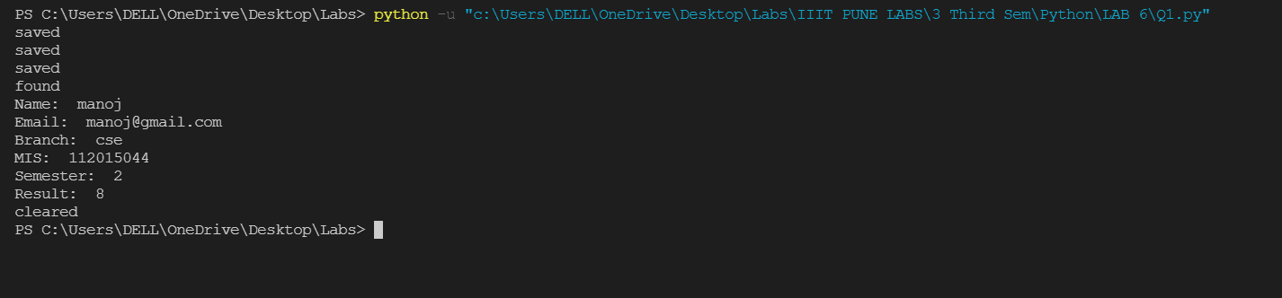

**Searched for manoj in above program.**

**Details in file**

